CHAPTER 8
On Tuesday they again did their laundry. The product of their efforts this time looked only slightly grayer than it had the time before. Claudia's sweater was considerably shrunken.
They knew that it was too early to get an answer to their letter, but they couldn't resist starting down to Grand Central Post Office to take a look anyway. It was noon by the time they stopped and ate breakfast at a Chock Full O'Nuts on Madison Avenue. They dragged it out beyond the patience of the people who were standing waiting to occupy their seats . Both Claudia and Jamie almost didn't want to look at their box in the post office. As long as they didn't look, they still had hopes that they could find a letter there .
They didn't. They strolled along the streets and found themselves near the United Nations building. Claudia suggested to Jamie that they take the guided tour she had read about when she was studying the Tour guide Book of the American Automobile Association.
"Today we can learn everything about the U.N."
Jamie's first question was, "How much?"
Claudia challenged him to walk in and find out. Fifty cents. Each. They could go if Claudia was willing to skip dessert that afternoon.
Jamie added, "You know, you can't have your cake and take tours, too."
"How about having tours and hot fudge sundaes, too?" Claudia asked.
They stood in line and got tickets for a tour. The girl selling tickets smiled down at them. "No school today?" she asked casually.
"No," Jamie answered. "The boiler on the furnace broke. No heat. They had to dismiss school. You should have heard the explosion! All the windows rattled. We thought it was an earthquake. Fourteen kids got cuts and abrasions, and their parents are suing the school to pay for their medical expenses. Well, it was about ten in. the morning. We had just finished our spelling lesson when . . . "
The man behind Jamie who was dressed in a derby hat and who looked more as if he belonged in the U.N. than visiting it said, "I say, what's holding up this line? I repeat, what is holding up this line?"
The girl gave Jamie the two tickets. As she did so, the man in the derby hat was already pushing his money onto the counter. The girl looked after Jamie and Claudia as they were leaving and said, "Where is . . . "
She couldn't finish her question. The man in the derby hat was scolding the girl. "No wonder it takes the U.N. forever to get something done. I've never seen a line move more slowly." He only looked as if he belonged; he certainly didn't act it.
The girl blushed as she gave the man his ticket. "I hope you enjoy your tour, sir." She acted as if she belonged.
Jamie and Claudia sat with other ticket holders waiting for their numbers to be called.
Claudia spoke softly to Jamie, "You sure are a fast thinker. Where did you cook up that story about the furnace?"
"I've had it ready and waiting ever since we left home. First chance I've had to use it," he answered.
"I thought I had thought of everything," Claudia said.
"That's O.K. "
"You're quite a kid."
"Thanks." Jamie smiled.
The guide who was calling the numbers finally said, "Will the people holding tickets number 106 to 121 please go to the double doors on the wall opposite this desk. There your guide will begin your tour."
Jamie and Claudia went. Their guide was an Indian girl who wore a sari and whose long hair was bound into a single braid that hung down her back to well below her waist. With one hand she lifted the folds of her sari; her walk was flavored by her costume: her steps were short and light and there appeared to be great movement around her knees. Claudia looked at her guide's skin and thought of smoky topaz: November, her mother's birthstone. She listened to her guide's accent and formed the sounds in her mind without listening to what the sounds said.
Thus, when the tour was finished, Claudia was no expert on the United Nations, but she had discovered something: saris are a way of being different. She could do two things, she decided. When she was grown, she could stay the way she was and move to some place like India where no one dressed as she did, or she could dress like someone else ?the Indian guide even and still live in an ordinary place like Greenwich.
"How did you like those ear phones where you can tune in almost any old language at all?" Jamie asked his sister. "Pretty keen, huh?"
Claudia seemed to have a faraway look in her eye.
"Yes," she answered. It sounded like "yah-ess." Jamie inspected Claudia closely. She was holding one arm crooked and the other pressed against her stomach. Her steps seemed shorter than usual and lighter than usual, and there appeared to be great movement around her knees.
"What's the matter with you?" he asked. "You got stomach cramps or something?"
Claudia lowered her eyes to him and said, "Jamie, you know, you could go clear around the world and still come home wondering if the tuna fish sandwiches at Chock Full O'Nuts still cost thirty-five cents."
"Is that what gave you stomach cramps?" he asked.
"Oh, just skip it! Just skip it." Claudia knew she would have to discover some other way to be different. Angel would help her somehow.
Her hopes centered more than ever on Box 847 in the post office, and the following day when they peeked through its little window, they saw an envelope. Claudia was prepared to be the discoverer of great truths, Greenwich's own heroine of the statue ?and only twelve years old. Jamie was so excited that he could hardly get the key into the lock to open the box. Claudia waited while he opened it and the envelope, too. He held the letter unfolded and off-center so that they could read it together. In silence .
Saxonberg, I have here attached a copy of the actual letter which I have in my files:
Dear Friends of the Museum:
We sincerely thank you for your interest in trying to help us solve the mystery of the statue. We have long known of the clue you mention; in fact, that clue remains our strongest one in attributing this work to the master, Michelangelo Buonarroti. Other evidence, however, is necessary, for it is known that Michelangelo did not carve all the marble blocks which were quarried for him and which bore his mark. We cannot ignore the possibility that the work may have been done by someone else, or that someone counterfeited the mark into the stone much later. We summarize the possibilities as follows:
1. The work was designed and done by Michelangelo himself.
2. The work was designed by Michelangelo but done by someone else.
3. The work was neither designed nor done by Michelangelo.
Our hope, of course, is to find evidence to support the first of these three possibilities .
Neither Condivi nor Vasari, Michelangelo's biographers who knew him personally mention the master carving this little angel; they mention only the angel carved for the altar in Siena. However, in a letter he wrote to his father from Rome on August 19, 1497, Michelangelo mentions ". . .I bought a piece of marble ... I keep to myself, and I am sculpturing an image for my own pleasure." In the past experts have believed the image which he sculptured for his own pleasure to be a cupid. Now, we must examine the possibility that it was an angel.
The problem of Angel has now become a matter for consensus. Four Americans, two Englishmen, and one German, all of whom are experts on the techniques of Michelangelo have thus far examined the statue. We are presently awaiting the arrival of two more experts from Florence, Italy. After all of these experts have examined the statue, we will write a summary of their opinions which we will release to the press.
We greatly appreciate your interest and would enjoy your disclosing further clues to us if you find them.
Sincerely,
Harold C. Lowery
Public Relations,
The Metropolitan Museum of Art

Claudia and Jamie walked from the post office to Grand Central Terminal and sat down in the waiting room. They sat perfectly quiet. Disappointed beyond words. Claudia would have felt better if the letter had not been so polite. A nasty letter or a sarcastic one can make you righteously angry, but what can you do about a polite letter of rejection? Nothing, really, except cry. So she did.
Jamie let her cry for a while. He sat there and fidgeted and counted the number of benches. She still cried; he counted the number of people on the benches. She was still at it; he alculated the number of people per bench .
After the big blobs of tears stopped, he said, "At least they treated us like grown-ups. That letter is full of big words and all."
"Big deal," Claudia sobbed. "For all they know, we are grown-ups." She was trying to find a corner of her shredded Kleenex that she could use.
Jamie let her sniff some, then he quietly asked, "What do we do now? Go home?"
"What? Go home now? We haven't even got our clothes. And your radio is in the violin case. We'd have to go home absolutely empty handed."
"We could leave our clothes; they're all gray anyway."
"But we never even used your radio. How can we face them at home? Without the radio and all. With nothing." She paused for a minute and repeated, "With nothing. We've accomplished nothing."
"We accomplished having fun," Jamie suggested. "Wasn't that what you wanted when we started out, Claude? I always thought it was."
Claudia began big tears again. "But that was then," she sobbed.
"You said you'd go home after you knew about Angel. Now you know."
"That's it," she sobbed. "I do not know."
"You know that you don't know. Just as the people at the museum don't know. C'mon," he pleaded, "we'll enjoy telling them about how we lived in the museum. The violin case can be evidence. Do you realize that we've lived there a whole week?"
"Yes," Claudia sighed. "Just a week. I feel as if I jumped into a lake to rescue a boy, and what I thought was a boy turned out to be a wet, fat log. Some heroine that makes. All wet for nothing." The tears flowed again .
"You sure are getting wet. You started this adventure just running away. Comfortably. Then the day before yesterday you decided you had to be a hero, too . "
"Heroine. And how should I have known that I wanted to be a heroine when I had no idea I wanted to be a heroine? The statue just gave me a chance . . . almost gave me a chance. We need to make more of a discovery. "
"So do the people at the museum. What more of a discovery do you think that you, Claudia Kincaid, girl runaway, can make? A tape recording of Michelangelo saying, 'I did it?' Well, I'll clue you in. They didn't have tape recorders 470 years ago."
"I know that. But if we make a real discovery, I'll know how to go back to Greenwich."
"You take the New Haven, silly. Same way as we got here." Jamie was losing patience.
"That's not what I mean. I want to know how to go back to Greenwich different."
Jamie shook his head. "If you want to go different, you can take a subway to 125th Street and then take the train."
"I didn't say differently, I said different. I want to go back different. I, Claudia Kincaid, want to be different when I go back. Like being a heroine is being different."
"Claudia, I'll tell you one thing you can do different . . ."
"Differently," Claudia interrupted.
"Oh, boloney, Claude. That's exactly it. You can stop ending every single discussion with an argument about grammar."
"I'll try," Claudia said quietly.
Jamie was surprised at her quiet manner, but he continued to be businesslike, "Now about this discovery."
"Jamie, I want to know if Michelangelo did it. I can't explain why exactly. But I feel that I've got to know. For sure. One way or the other. A real discovery is going to help me."
"If the experts don't know for sure, I don't mind not knowing. Let's get tickets for home." Jamie started toward the New Haven ticket window. Claudia stayed behind. Jamie realized that she was not following, returned to her, and lectured, "You're never satisfied, Claude. If you get all A's, you wonder where are the pluses. You start out just running away, and you end up wanting to know everything. Wanting to be Joan of Arc, Clara Barton, and Florence Nightingown all in one."
"Nightingale," Claudia sighed. She got up then and followed slowly behind her brother. But she was feeling too low to go home. She couldn't.
She just couldn't. It just wasn't right.
There were only two windows that didn't say, "Closed." They waited a short while as the man in front of them purchased a red commuter's pass like the one that had brought them to Manhattan.
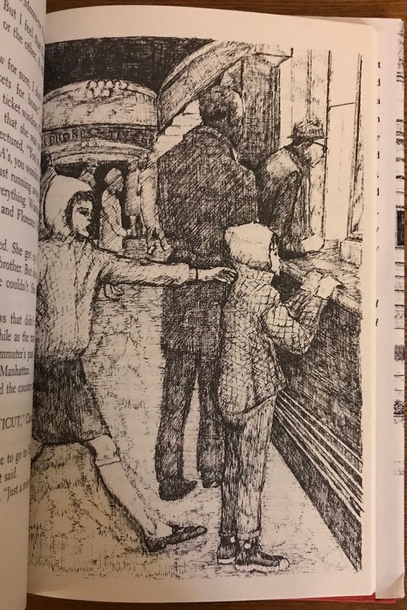
Jamie addressed the man behind the counter and said, "Two half-fare tickets for . . ."
"FARMINGTON, CONNECTICUT," Claudia broke in.
"To get to Farmington, you have to go to Hartford and take a bus," the ticket agent said.
Jamie nodded to the man and said, "Just a minute, please." He stepped away from the window, grabbing Claudia's arm. He pulled her away.
Claudia whispered, "Mrs. Basil E. Frankweiler."
"What about Mrs. Basil E. Frankweiler?"
"She lives in Farmington."
"So what?" Jamie said. "The paper said that her house was closed."
"Her New York house was closed. Can't you read anything right?"
"You talk that way, Claude, and ..."
"All right, Jamie. All right. I shouldn't talk that way. But, please let's go to Farmington. Jamie, please. Can't you see how badly I need to find out about Angel? I just have a hunch she'll see us and that she knows."
"I've never known you to have a hunch before, Claude. You usually plan everything. "
"I have, too, had a hunch before."
"When?"
"That night they moved the statue and I stayed in the washroom and didn't get caught. That was a hunch. Even if I didn't know it was a hunch at the time."
"O.K. We'll go to Farmington," Jamie said. He marched to the ticket window and bought passage to Hartford.
They were waiting at track twenty-seven when Claudia said to Jamie, "That's a first for you, too."
"What is?" he asked.
"Buying something without asking the price first."
"Oh, I must have done that before now," he answered.
"When? Name one time."
"I can't think of it right now." He thought a minute then said, "I haven't been a tightwad all my life, have I?"
"As long as I've known you," Claudia answered.
"Well, you've known me for as long as I've known me," he said smiling.
"Yes," Claudia said, "I've been the oldest child since before you were born."
They enjoyed the train ride. A large portion of it went over track they had never before seen. Claudia arrived in Hartford feeling much happier than she had since they received the morning's mail. Her self-assurance had returned to her.
The Hartford station was on Farmington Avenue. Claudia reasoned that they could not be far from Farmington itself. Why take a bus and worry about which stop to get off? Without consulting Jamie she hailed a cab. When it stopped, she got in; Jamie followed. Claudia told the driver to take them to the house of Mrs. Basil E. Frankweiler in Farmington, Connecticut. Claudia sat back. In a taxi at last.
(And that, Saxonberg, is how I enter the story. Claudia and Jamie Kincaid came to see me about Angel.)

