CHAPTER 7
When they left the museum on Monday morning, Claudia walked to the bus stop without even consulting Jamie.
"Don't you think we ought to get breakfast first?" He asked.
"Mail early in the day," Claudia answered. "Besides, we want them to get this letter as soon as possible."
"It will get there faster if we deliver it by hand," Jamie suggested.
"Good idea. We'll get our mailbox number, write it in, and then take it to the museum office."
Since Jamie was official treasurer of the team, it was he who approached the man behind the cage window at the post office.
"I would like to rent a post office box," he declared.
"For how long?" the man inquired.
"For about two days."
"Sorry," the man said, "we rent them quarterly." "All right, then. I'll take eight quarterlies. That makes two days."
"Quarter of a year," the man said. "That makes three months."
"Just a minute," Jamie said. He held a whispered conference with Claudia.
"Go ahead. Rent it," she urged.
"It'll cost a stack of money."
"Why don't you find out instead of arguing about it now?" Claudia's whisper began to sound like cold water hitting a hot frying pan.
"How much will a quarter of a year be?" he asked the postman.
"Four dollars and fifty cents."
Jamie scowled at Claudia. "See. I told you a stack."
Claudia shrugged her shoulders, "We'll take a long, long bath tonight."
The postman hardly looked puzzled. People working at the Grand Central Post Office grow used to strange remarks. They hear so many. They never stop hearing them; they simply stop sending the messages to their brains. Like talking into a telephone with no one on the receiver end. "Do you or don't you want it?" he asked.
"I'll take it."
Jamie paid the rent, signed a form using the name Angelo Michaels and gave his address as Marblehead, Massachusetts. He received a key to Box Number 847. Jamie-Angelo-Kincaid-Michaels felt important having a key to his own mailbox. He found his box and opened the little door.
"You know," he remarked to Claudia, "it's a lot like Horn and Hardart's. Except that we could have a complete spaghetti dinner for both of us coming out of the little door instead of just empty, empty space.
Paying four dollars and fifty cents for empty space had been hard on Jamie. Claudia knew they wouldn't take a bus back to the museum. They didn't .
Both Claudia and Jamie wanted to deliver the letter, but neither thought he should. Too risky. They decided to ask someone to deliver it for them. Someone with a bad memory for faces. Someone their own age would be best; someone who might be nosey but who wouldn't really care about them. It would be easiest to find a school group and select their messenger. They began their search for the group of the day by looking in the usual places: Arms and Armor, the Costume Institute, and Egyptian Art. As they approached the Egyptian wing, they heard the shuffling of feet and a sound they recognized as the folding of chairs and the gathering up of rubber mats. They weren't anxious to hear the talk about mummies again; they never watched repeats on television, either. But they decided to look the group over. So they waited inside the tomb.
(Now, Saxonberg, I must tell you about that Egyptian tomb called a mastaba. It is not a whole one; it is the beginning of one. You can walk into it. You can spend a lot of time in it, or you can spend very little time in it. You can try to read the picture writing on the walls. Or you can read nothing at all. Whether you read or not, whether you spend a lot of time or a little in that piece of Ancient Egypt, you will have changed climate for at least that part of your day. It is not a hard place to wait in at all . )
The group was moving past the entrance. Claudia and Jamie were relaxed and waiting ?wrapped up in the vacuum of time created by those warm stone walls. Puffs of conversation broke the silence of their tomb.
"Sarah looks like pharaoh. Pass it on."
"When are we gonna eat?"
"Man, what a lot of walking."
The conversation rained in softly and comfortably and told the two stowaways that they had the correct age group. That was the way kids in their classes always talked. Words continued to drizzle into their shelter.
"Hey, Rube, look at this."
"C'mon, Bruce, let me borrow it."
Something else now showered down upon them. Something much less comfortable. Familiarity! The names, Sarah, Bruce, Rube, were familiar . . . Ages ago, in time well outside the mastaba, they had heard these names -in a classroom, on a school bus . . .
Closer, louder, the sounds poured in. Then one small cloud burst right outside their door.
"Hey, let's go back in here."
Jamie's eyes caught Claudia's. He opened his mouth. Claudia didn't wait to discover whether he opened it in surprise or to say something. She clamped her hand over his mouth as fast as she could.
An adult voice urged, "Come on, boys. We have to stay with the group."
Claudia took her hand from Jamie's mouth. She looked at him solemnly and nodded yes. The "come-on-boys" voice belonged to Miss Clendennan, Jamie's third grade teacher. Rube was Reuben Hearst, and Bruce was Bruce Lansing. Sarah was Sarah Sawhill, and unfortunately, she did look a great deal like pharaoh. Believe it or not, the mountain had come to Mohammed; their school had come to them. At least, Jamie's class had.
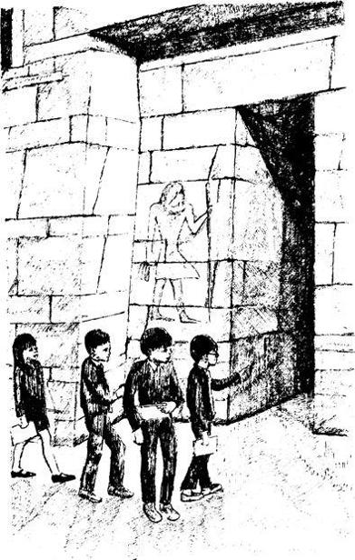
Jamie was furious. Why had Claudia muzzled him? Did she think he had no sense at all? He pulled his eyebrows down and made his best possible scowl. Claudia held her finger up to her lips and signaled him to stay quiet yet. The sounds of third grade shuffling and third grade jostling faded from their shelter. The quiet of the ages returned to the tomb.
But not to Jamie. He couldn't contain himself another minute. He could still feel the pressure of Claudia's hand over his mouth. "I have half a mind to join that group and go back with them and just be mysterious about where I came from."
"If you do that, it'll show that you have half a mind. Exactly half. Only half. Something I've suspected for a long time. You can't even see that this is perfect."
"How perfect?"
Claudia slowed down. "You go to the museum office. Deliver the letter. Tell them you are in the third grade group that is visiting from Greenwich and someone asked you to deliver the letter. The teacher said it would be O.K. If they ask you your name, say Bruce Lansing. But only if they ask."
"You know, Claude, when I'm not wishing I could give you a sock right in the nose, I'm glad you're on my team. You're smart even if you're hard to live with."
"You'll do it then?" Claudia asked.
"Yeah, I'll do it. It is perfect."
"Let's hurry before they come back."
Jamie entered the museum office, and Claudia stood guard outside the door. She intended to step inside the office if she spotted the class returning. Jamie wasn't gone long. Everything had gone well, and they hadn't asked his name. Claudia grabbed his arm as he came out. All the energy of Jamie's wound up nerves let loose. He collapsed as hard as if Claudia had suddenly jumped off the down end of a teeter-totter while he was still sitting on the up end.
"Yikes!" he yelled. Claudia was tempted to muzzle him again, but didn't. Instead she led him out the door into the Fifth Avenue crowd and began walking uptown with him as fast as she could go.

