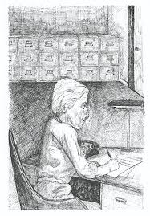
To my lawyer, Saxonberg:
I can’t say that I enjoyed your last visit. It was obvious that you had too much on your mind to pay any attention to what I was trying to say. Perhaps, if you had some interest in this world besides law, taxes and your grandchildren, you could almost be a fascinating person. Almost. That last visit was the worst bore. I won’t risk another dull visit for a while, so I’m having Sheldon, my chauffeur, deliver this account to your home. I’ve written it to explain certain changes I want made in my last will and testament. You’ll understand those changes (and a lot of other things) much better after reading it. I’m sending you a carbon copy; I’ll keep the original in my files. I don’t come in until much late, but never mind. You’ll find enough to interest you until I do.
You never knew that I could write this well, did you? Of course, you don’t actually know yet, but soon will. I’ve spent a lot of time on this file. I listened I investigated, and I fitted all the pieces together like a jigsaw puzzle. It leave no doubts. Well, Saxonberg, read and discover.
Mrs. Basil E. Frankweiler

CHAPTER 1
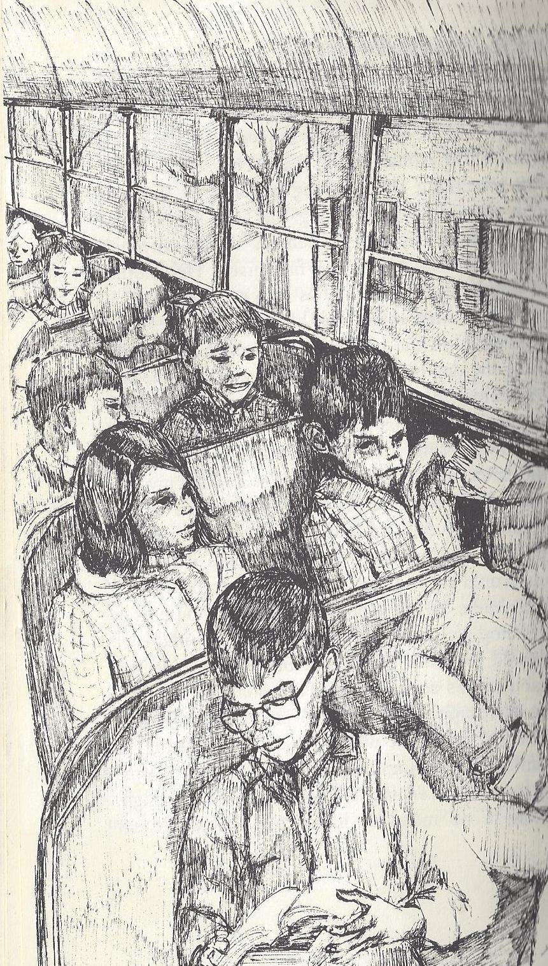
You never knew that I could write this well, did you? Of course, you don’t actually know yet, but you soon will. Ibe spent a lot of time on this file. I listened. I nvestigate, and I fitted all the piecces
Claudia knew that she could never pull off the old-fashioned kind of running away. That is, running away in the heat of anger with a knapsack on her back. She didn't like discomfort; even picnics were untidy and inconvenient: all those insects and the sun melting the icing on the cupcakes. Therefore, she decided that her leaving home would not be just running from somewhere but would be running to somewhere. To a large place, a comfortable place, an indoor place, and preferably a beautiful place. And that's why she decided upon the Metropolitan Museum of Art in New York City.
She planned very carefully; she saved her allowance and she chose her companion. She chose Jamie, the second youngest of her three younger brothers. He could be counted on to be quiet, and now and then he was good for a laugh. Besides, he was rich; unlike most boys his age, he had never even begun collecting baseball cards. He saved almost every penny he got.
But Claudia waited to tell Jamie that she had decided upon him. She couldn't count on him to be that quiet for that long. And she calculated needing that long to save her weekly allowances. It seemed senseless to run away without money. Living in the suburbs had taught her that everything costs.
She had to save enough for train fare and a few expenses before she could tell Jamie or make final plans. In the meantime she almost forgot why she was running away. But not entirely. Claudia knew that it had to do with injustice. She was the oldest child and the only girl and was subject to a lot of injustice. Perhaps it was because she had to both empty the dishwasher and set the table on the same night while her brothers got out of everything. And, perhaps, there was another reason more clear to me than to Claudia. A reason that had to do with the sameness of each and every week. She was bored with simply being straight-A's Claudia Kincaid. She was tired of arguing about whose turn it was to choose the Sunday night seven-thirty television show, of injustice, and of the monotony of everything.
The fact that her allowance was so small that it took her more than three weeks of skipping hot fudge sundaes to save enough for train fare was another example of injustice. (Since you always drive to the city, Saxonberg, you probably don't know the cost of train fare. I'll tell you. Full fare one way costs one dollar and sixty cents. Claudia and Jamie could each travel for half of that since she was one month under twelve, and Jamie was well under twelve ?being only nine.) Since she intended to return home after everyone had learned a lesson in Claudia appreciation, she had to save money for her return trip, too, which was like full fare one way. Claudia knew that hundreds of people who lived in her town worked in offices in New York City and could afford to pay full fare both ways every day. Like her father. After all, Greenwich was considered an actual suburb of New York, a commuting suburb.
Even though Claudia knew that New York City was not far away, certainly not far enough to go considering the size and number of the injustices done to her, she knew that it was a good place to get lost. Her mother's Mah-Jong club ladies called it the city. Most of them never ventured there; it was exhausting, and it made them nervous. When she was in the fourth grade, her class had gone on a trip to visit historical places in Manhattan. Johnathan Richter's mother hadn't let him go for fear he'd get separated from the group in all the jostling that goes on in New York. Mrs. Richter, who was something of a character, had said that she was certain that he would "come home lost." And she considered the air very bad for him to breathe.
Claudia loved the city because it was elegant; it was important; and busy. The best place in the world to hide. She studied maps and the Tour guide book of the American Automobile Association and reviewed every field trip her class had ever taken. She made a specialized geography course for herself. There were even some pamphlets about the museum around the house, which she quietly researched.
Claudia also decided that she must get accustomed to giving up things. Learning to do without hot fudge sundaes was good practice for her. She made do with the Good Humor bars her mother always kept in their freezer. Normally, Claudia's hot fudge expenses were forty cents per week. Before her decision to run away, deciding what to do with the ten cents left over from her allowance had been the biggest adventure she had had each week. Sometimes she didn't even have ten cents, for she lost a nickel every time she broke one of the household rules like forgetting to make her bed in the morning. She was certain that her allowance was the smallest in her class. And most of the other sixth graders never lost part of their pay since they had full-time maids to do the chores instead of a cleaning lady only twice a week. Once after she had started saving, the drug store had a special. HOT FUDGE, 27c, the sign in the window said. She bought one. It would postpone her running away only twenty-seven cents worth. Besides, once she made up her mind to go, she enjoyed the planning almost as much as she enjoyed spending money. Planning long and well was one of her special talents.
Jamie, the chosen brother, didn't even care for hot fudge sundaes although he could have bought one at least every other week. 'A year and a half before, Jamie had made a big purchase; he had spent his birthday money and part of his Christmas money on a transistor radio, made in Japan, purchased from Woolworth's. Occasionally, he bought a battery for it. They would probably need the radio; that made another good reason for choosing Jamie.
On Saturdays Claudia emptied the wastebaskets, a task she despised. There were so many of them. Everyone in her family had his own bedroom and wastebasket except her mother and father who shared both with each other. Almost every Saturday Steve emptied his pencil sharpener into his. She knew he made his basket messy on purpose.
One Saturday as she was carrying the basket from her parent's room, she jiggled it a little so that the contents would sift down and not spill out as she walked. Their basket was always so full since there were two of them using it. She managed to shift a shallow layer of Kleenex, which her mother had used for blotting lipstick, and thus exposed the corner of a red ticket. Using the tips of her forefinger and thumb like a pair of forceps, she pulled at it and discovered a ten ride pass for the New York, New Haven, and Hartford Railroad. Used train passes normally do not appear in suburban wastebaskets; they appear in the pockets of train conductors. Nine rides on a pass are marked off in little squares along the bottom edge, and they are punched one at a time as they are used; for the tenth ride the conductor collects the pass. Their cleaning lady who had come on Friday must have thought that the pass was all used up since rides one through nine were already punched. The cleaning lady never went to New York, and Claudia's dad never kept close track of his pocket change or his train passes.
Both she and Jamie could travel on the leftover pass since two half fares equal one whole. Now they could board the train without having to purchase tickets. They would avoid the station master and any stupid questions he might ask. What a find! From a litter of lipstick kisses, Claudia had plucked a free ride. She regarded it as an invitation. They would leave on Wednesday.
On Monday afternoon Claudia told Jamie at the school bus stop that she wanted him to sit with her because she had something important to tell him. Usually, the four Kincaid children neither waited for each other nor walked together, except for Kevin who was somebody's charge each week. School had begun on the Wednesday after Labor Day. Therefore, their "fiscal week" as Claudia chose to call it began always on Wednesday. Kevin was only six and in the first grade and was made much over by everyone, especially by Mrs. Kincaid, Claudia thought. Claudia also thought that he was terribly babied and impossibly spoiled. You would think that her parents would know something about raising children by the time Kevin, their fourth, came along. But her parents hadn't learned. She couldn't remember being anyone's charge when she was in the first grade. Her mother had simply met her at the bus stop every day.
Jamie wanted to sit with his buddy, Bruce. They played cards on the bus; each day meant a continuation of the day before. (The game was nothing very complicated, Saxonberg. Nothing terribly refined. They played war, that simple game where each player puts down a card, and the higher card takes both. If the cards are the same, there is a war which involves putting down more cards; winner then takes all the war cards.) Every night when Bruce got off at his stop, he'd take his stack of cards home with him. Jamie would do the same. They always took a vow not to shuffle. At the stop before Bruce 's house, they would stop playing, wrap a rubber band around each pile, hold the stack under each other's chin and spit on each other's deck saying, "Thou shalt not shuffle." Then each tapped his deck and put it in his pocket.
Claudia found the whole procedure disgusting, so she suffered no feelings of guilt when she pulled Jamie away from his precious game. Jamie was mad, though. He was in no mood to listen to Claudia. He sat slumped in his seat with his lips pooched out and his eyebrows pulled down on top of his eyes. He looked like a miniature, clean-shaven Neanderthal man. Claudia didn't say anything. She waited for him to cool off.
Jamie spoke first, "Gosh, Claude, why don't you pick on Steve?"
Claudia answered, "I thought, Jamie, that you'd see that it's obvious I don't want Steve."
"Well, " Jamie pleaded, "want him! Want him! "
Claudia had planned her speech. "I want you, Jamie, for the greatest adventure in our lives."
Jamie muttered, "Well, I wouldn't mind if you'd pick on someone else."
Claudia looked out the window and didn't answer. Jamie said, "As long as you've got me here, tell me."
Claudia still said nothing and still looked out the window. Jamie became impatient. "I said that as long as you've got me here, you may as well tell me. "
Claudia remained silent. Jamie erupted, "What's the matter with you, Claude? First you bust up my card game, then you don't tell me. It's undecent . "
"Break up, not bust up. Indecent, not undecent," Claudia corrected.
"Oh, boloney! You know what I mean. Now tell me," he demanded.
"I've picked you to accompany me on the greatest adventure of our mutual lives," Claudia repeated.
"You said that." He clenched his teeth. "Now tell me." I've decided to run away from home, and I've chosen you to accompany me . “
"Why pick on me? Why not pick on Steve?" he asked.
Claudia sighed, "I don't want Steve. Steve is one of the things in my life that I'm running away from. I want you."
Despite himself, Jamie felt flattered. (Flattery is as important a machine as the lever, isn't it, Saxonberg? Give it a proper place to rest, and it can move the world.) It moved Jamie. He stopped thinking, "Why pick on me?" and started thinking, "I am chosen." He sat up in his seat, unzipped his jacket, put one foot up on the seat, placed his hands over his bent knee and said out of the corner of his mouth, "O.K., Claude, when do we bust out of here? And how?"
Claudia stifled the urge to correct his grammar again. "On Wednesday. Here's the plan. Listen carefully."
Jamie squinted his eyes and said, "Make it complicated, Claude. I like complications . "
Claudia laughed. "It's got to be simple to work. We'll go on Wednesday because Wednesday is music lesson day. I'm taking my violin out of its case and am packing it full of clothes . You do the same with your trumpet case. Take as much clean underwear as possible and socks and at least one other shirt with you."
"All in a trumpet case? I should have taken up the bass fiddle."
"You can use some of the room in my case. Also use your book bag. Take your transistor radio."
"Can I wear sneakers?" Jamie asked.
Claudia answered, "Of course. Wearing shoes all the time is one of the tyrannies you'll escape by coming with me."
Jamie smiled, and Claudia knew that now was the correct time to ask. She almost managed to sound casual. "And bring all your money." She cleared her throat. "By the way, how much money do you have?"
Jamie put his foot back down on the floor, looked out the window and said, "Why do you want to know?"
"For goodness' sake, Jamie, if we're in this together, then we're together. I've got to know. How much do you have?"
"Can I trust you not to talk?" he asked.
Claudia was getting mad. "Did I ask you if I could trust you not to talk?" She clamped her mouth shut and let out twin whiffs of air through her nostrils; had she done it any harder or any louder, it would have been called a snort.
"Well, you see, Claude," Jamie whispered, "I have quite a lot of money. "
Claudia thought that old Jamie would end up being a business tycoon someday. Or at least a tax attorney like their grandfather. She said nothing to Jamie.
Jamie continued, "Claude, don't tell Mom or Dad, but I gamble. I play those card games with Bruce for money. Every Friday we count our cards, and he pays me. Two cents for every card I have more than he has and five cents for every ace. And I always have more cards than he has and at least one more ace. "
Claudia lost all patience. "Tell me how much you have! Four dollars? Five? How much?"
Jamie nuzzled himself further into the corner of the bus seat and sang, "Twenty-four dollars and forty- three cents." Claudia gasped, and Jamie, enjoying her reaction, added, "Hang around until Friday and I'll make it twenty- five even."
"How can you do that? Your allowance is only twenty-five cents. Twenty-four forty-three plus twenty-five cents makes only twenty-four dollars and sixty-eight cents." Details never escaped Claudia.
"I'll win the rest from Bruce."
"C'mon now, James, how can you know on Monday that you'll win on Friday?"
"I just know that I will," he answered.
"How do you know?"
"I'll never tell." He looked straight at Claudia to see her reaction. She looked puzzled. He smiled, and so did she, for she then felt more certain than ever that she had chosen the correct brother for a partner in escape. They complemented each other perfectly. She was cautious (about everything but money) and poor; he was adventurous (about everything but money) and rich. More than twenty-four dollars. That would be quite a nice boodle to put in their knapsacks if they were using knapsacks instead of instrument cases. She already had four dollars and eighteen cents. They would escape in comfort.
Jamie waited while she thought. "Well? What do you say? Want to wait until Friday?"
Claudia hesitated only a minute more before deciding, "No, we have to go on Wednesday. I'll write you full details of my plan. You must show the plan to no one. Memorize all the details; then destroy my note."
"Do I have to eat it?" Jamie asked.
"Tearing it up and putting it in the trash would be much simpler. No one in our family but me ever goes through the trash. And I only do if it is not sloppy and not full of pencil sharpener shavings. Or ashes."
I'll eat it. I like complications," Jamie said.
"You must also like wood pulp," Claudia said. "That's what paper is made of, you know."
"I know. I know," Jamie answered. They spoke no more until they got off the bus at their stop. Steve got off the bus after Jamie and Claudia.
Steve yelled, "Claude! Claude! It's your turn to take Kevin. I'll tell Mom if you forget."
Claudia who had been walking up ahead with Jamie stopped short, ran back, grabbed Kevin's hand and started retracing her steps, pulling him along to the side and slightly behind.
"I wanna walk with Stevie, " Kevin cried.
"That would be just fine with me, Kevin Brat," Claudia answered. "But today you happen to be my responsibility."
"Whose ' sponsibility am I next?" he asked.
"Wednesday starts Steve's turn," Claudia answered.
"I wish it could be Steve's turn every week," Kevin whined.
"You just may get your wish."
Kevin never realized then or ever that he had been given a clue, and he pouted all the way home.

